Checklist for events of the Entrepreneurs Forum:

- Prepare PowerPoint Introduction, Event Agenda, Speaker Bios (Russ Frandsen normally prints them)

- Bring your own laptop

- Ensure Maureen Whalen is CC'ed on all emails concerning logistics.

- Maureen will prepare catering, registration and nametags and print the event handouts (Agenda, Speaker Bios and Ratings Form)

- Reserve 4 microphones with Chris Mach, the Cahill lead. His email is cmach@alice.caltech.edu but Lynn or Maureen will verify this also. (in bottom right side drawer of podium, are two lavaliere and one wireless mics in black pouches)

- If the doors are locked Saturday morning, call Security Dispatch at (626) 395-3164 and they will send someone.

- Have Speakers sign the AV Release Form if the event is being recorded.

- Have Speaker email their presentations or load them from memory sticks prior to the event. Best to have presentations queued up for quicker transitions between speakers.

The following Checklist is for often used by Producers/Moderators at the start of events:
- Remind attendees to turn off cell phones.

- Remind speakers to speak close to the microphone (swallow the mic)

- Highlight that free WiFi is available from "Caltech Guest" (this is highlighted on the opening PPT Slide).

- Switch from the rotating PPT deck to a static PPT presentation - leave the presentation on the Intro slide at the beginning of the event so the rotating slides aren't distracting.

- Show the sponsor PPT slide and thank them for their support.

At the end of the program:
- Remind attendees to fill out the ratings questionnaire on Survey Monkey when it is emailed to them.

- Thank the speakers and give them the Caltech Mugs as gifts of the Committee.

The following Checklist is for starting the AV System and Video Recording at Hameetman Events:

Touch the AV Screen to start the AV Control Screen shown below:
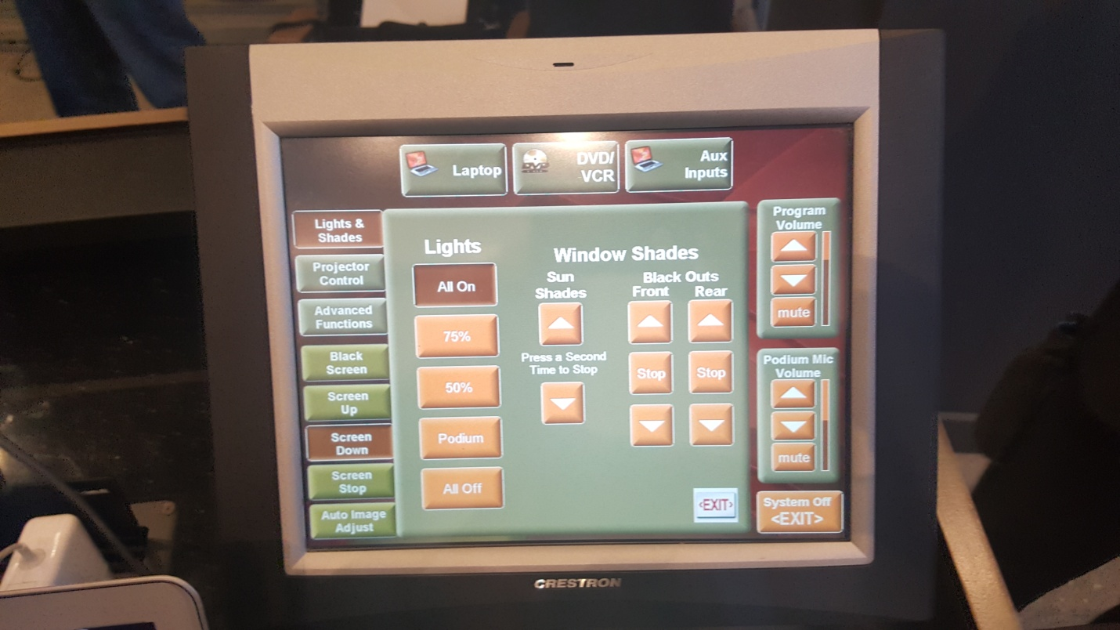

From the Icon at the Top Left of the screen marked "Lights & Shades", we usually turn the Window Shades “Front Black Outs” all the way down and the “Rear Black Outs” halfway down. Then tap the Lights “50%” button for the program.
If you have any video content during the program, you can push the Lights “podium” button that will dim the lights so the video can be better seen.

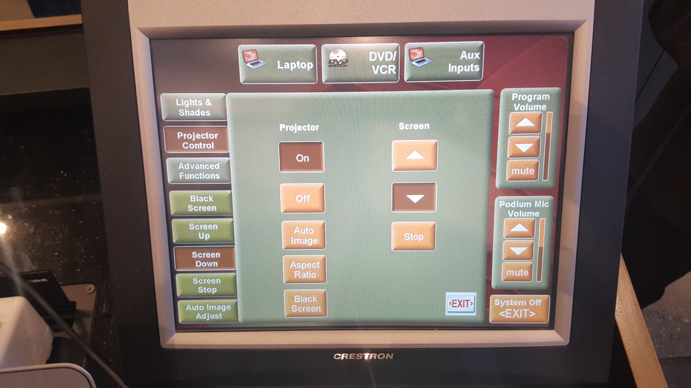

From the left side "Projector Control" icon, hit the down button under "Screen" until the projection screen is all the way down, and make sure to push the Projector “On” button.

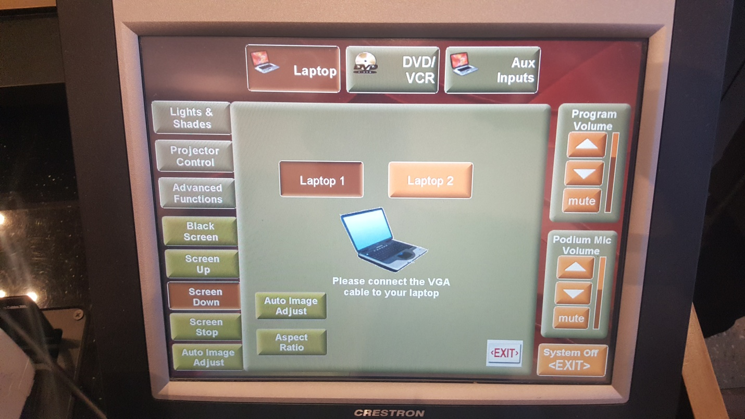

Push the "Laptop" icon at the top of the screen, and choose "Laptop 1" or "Laptop 2" and plug them in with the attached cords.

If we are videotaping the event from the Echo360 system, just as you are starting the program, push the Green power button to turn it on (verify by looking at the camera at the back of room that the green light on it is “on”), then push "1" to video the speaker at the podium and "5" to video the entire stage for the panel discussion.
At the end of the program, push the green button again to shut the camera off.
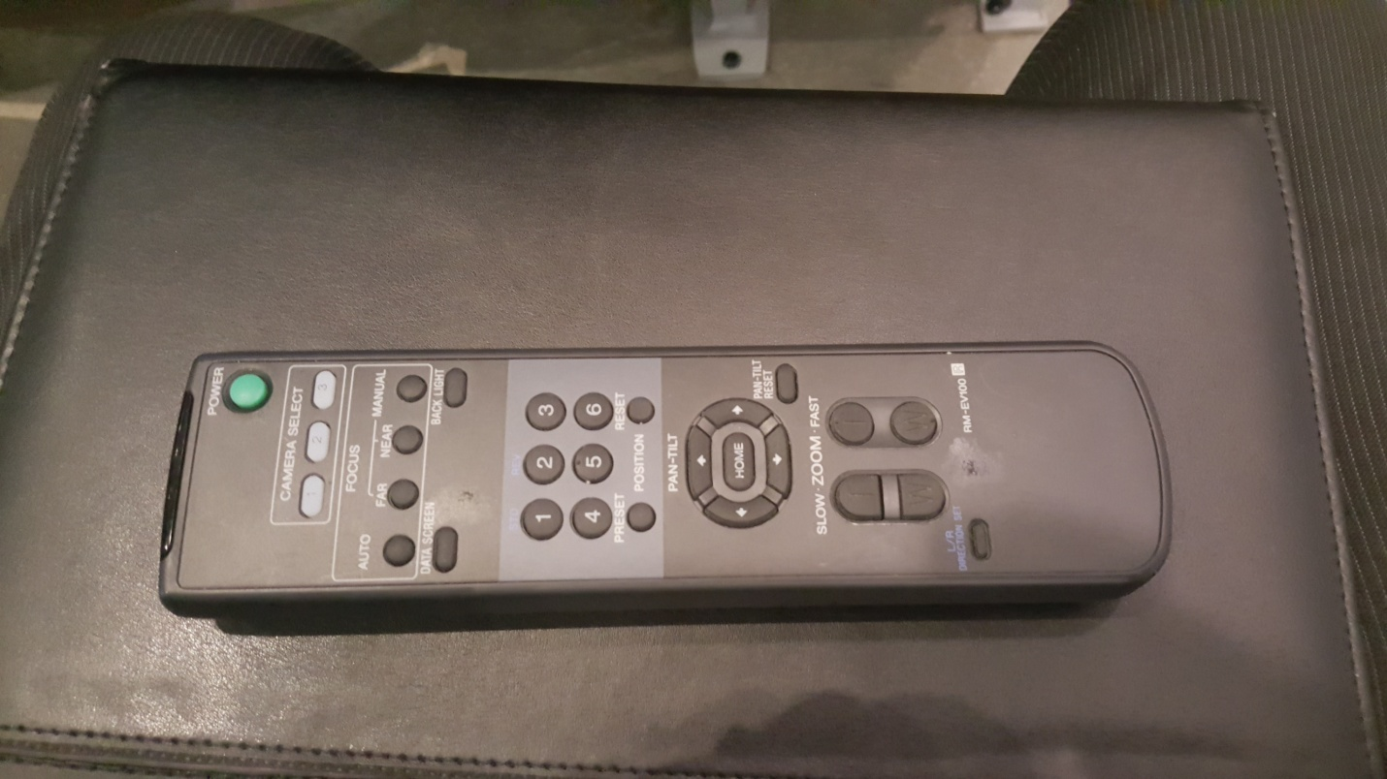

AT THE END OF THE PROGRAM:

- BRING THE ROOM TO 100% LIGHTING,

- OPEN ALL SIDE WINDOW BLINDS TO FULL HEIGHT, AND

- RETURN TWO LAVALIERE AND ONE WIRELESS MICS TO THE BLACK ZIP BAGS AND PUT THEM INTO BOTTOM RIGHT DRAWER AT PODIUM.

